**Welcome User**

Create a MVC application to get user name and display user name.  
  
Consider a Controller named **MessageController** and define the following method,

|  |  |
| --- | --- |
| **Method Name** | **Description** |
| public ActionResult Index() | This method returns the View that gets the input from the user. |
| public ActionResult DisplayName() | This method returns the view that displays the welcome message along with user name. |

Create the following views for the **MessageController** with Razor View Engine,

* **Index.cshtml** for the Index method to get the user name as input from the user.
* **DisplayName.cshtml** for the DisplayName method to display the welcome message.

**Note : Make sure the UI constraints like element names, id's, UI design, element order, alignment and field labels should be followed as specified in the mock-up screen.**

**Screenshot 1 (Index.cshtml) :  
  
https://hcl.e-box.co.in/uploads/Image/9241/9241.PNG  
  
Screenshot 2 (Index.cshtml) :**  
  
https://hcl.e-box.co.in/uploads/Image/9241/9241-3.PNG

**UI Constraints :**

**Screenshot 1 :**

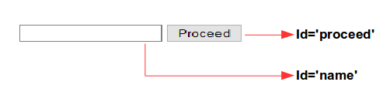  
  
  
**Screenshot 2 :**  
  


**Rent Calculation**

Cassandra and her friends are doing their higher education. They started their internships in Eventsforce. Cassandra and her friends were assigned with an ASP.NET MVC application. The requirement is to get the hall details and calculate the rent amount. Help them to create an ASP.NET MVC application.  
  
Consider a Controller named **HomeController** and define the following methods

|  |  |
| --- | --- |
| **Method Name** | **Description** |
| public ActionResult Index() | This method returns the Index View that contains a form to get hall details from user. |
| public ActionResult Calculate() | This method used to calculate the rent amount based on the start and end date. And returns Calculate View. |

**Page Flow :**  
1. Create the following views for the HomeController class with Razor View Engine,  
2. Create a View named **Index.cshtml** for the Index method that contains a form to get input hall details from user. When Calculate button is clicked, the hall details are passed to Calculate method.  
3. Create a View named **Calculate.cshtml** for the Calculate method that displays the form details of hall with rent amount.  
  
  
  
**Note:**  
The date format should be “**dd-MM-yyyy**”.

**Note : Make sure the UI constraints like element names, id's, UI design, element order, alignment and field labels should be followed as specified in the mock-up screen.**

**Screenshot 1 (Index.cshtml):**  
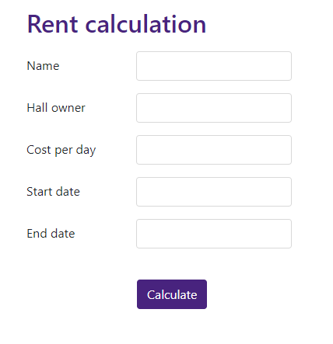  
  
**Screenshot 2 (Index.cshtml):**  
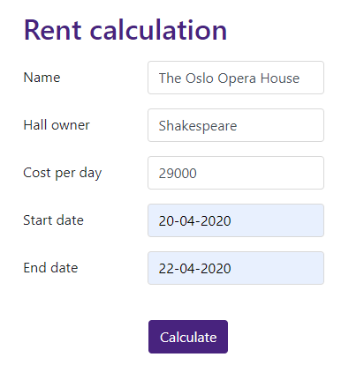  
  
**Screenshot 3 (Calculate.cshtml):**  
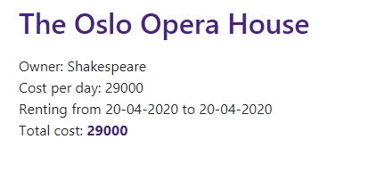  
  
  
**UI Constraints :**  
**Screenshot 1:**  
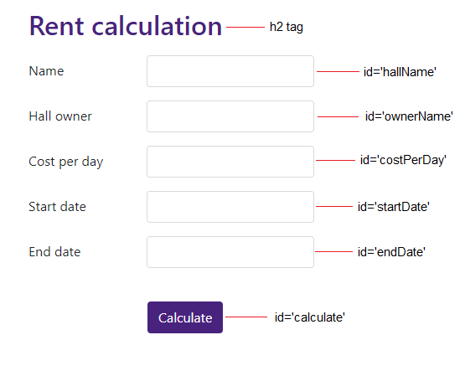  
  
**Screenshot 2:**  


